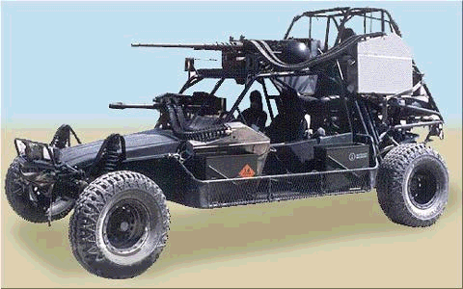
Lockheed Fast Advance Vehicle Generation II

The second generation of the Fast Advance Vehicle is a great improvement over the first generation. The second generation is faster, can carry more people, and has greater armorment. The FAV's are designed for quick runs into enemy territory, usually used to rescue downed pilots, or pick up operatives. The FAV II replaces the LMG and the Rocket launcher with the new HK GMG, a Stoner M107 and a FN-Mag 5 providing greater power. The GMG and the M107 are mounted on fixed hardpoints, while the FN is mounted on a aft facing ring mount. The FAV II is much quieter than standard rescue methods due to the fact that it uses an electic engine as compared to a gasoline or methane engine.
Handling | Speed | Accel | Body | Armour | Sig
4/4 | 150 | 9 | 3 | 0 | 5
Autonav | Pilot | Sensor | Cargo | Load
3 | NA | 5 | 4 | 37
Seating | 2b+1b+1b |  |  | Setup/Breakdown |  |  | N/A
Entry | Open |  |  | Landing/Takeoff |  |  | NA
Fuel | Electic 300 PF |  |  | Economy |  |  | 2.5 km/PF
DP Cost | 1222 |  |  | Cost |  |  | 245,000
Template | Sand Buggy |  |  | Reference |  |  | The Shop
Features | Datajack Port  Rigger Adaptation  Suncell Power  Advanced Passenger Protection System  Roll Bars  Electronics Port  External Hardpoint ^{W}/ Maintech “Dasva” HMG ^{W}/ 500 APDS rounds  External Hardpoint (Passenger Side) ^{W}/ Ares MP Grenade Launcher ^{W}/ 400 mini-grenades  Ring Mount (Facing Aft) ^{W}/ FN-MAG 5 ^{W}/ 250 APDS rounds  Hood Mounted (Forward arch) Ares MP Torch ^{W}/(200) Charges  Smartlink Integration Level II  Off-Road Runflat Tires  (4) Tube Missile Rack ^{W}/ Ares-UCAS “Cougar” LRHEM’s

